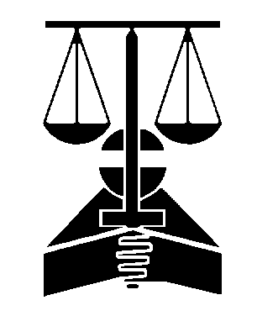
STATE BAR OF GEORGIA

MEMBERSHIP
104 MARIETTA STREET
SUITE 100
ATLANTA GA 30303

EMAIL TO: MEMBERSHIP@GABAR.ORG

Please be advised that the following attorney has changed their name. Bar Number
____________________
____________________________________
Current name on Bar Membership Records

Please change the current name on Bar Membership Records to reflect the new name below (copy of legal document that changed name must be provided). (Sign and Date Below)
_______________________
_______________________
_______________________

New Name

First

Middle Last

If you need to update your address, please indicate whether the below is information for your official address or home address.

Address
______________________________________________
____________________
__________
p_________

City State Zi Telephone Number
______________________
_______________________________________
Email

Please make the above referenced change in my records. If you have any further questions regarding this matter please call me at
______________________.

(Sign name here) (Date)
____________________________

Questions: Email membership@gabar.org

